

**CSF 3133**

**WEB-BASED INTERFACE DESIGN**

**LAB REPORT 2**

NAME: NIK MARIYAH SOFEAH BINTI MOHD RIZAN

MATRIC NUMBER: S76237

GROUP: K4

LECTURER: PROF. MADYA TS. DR WAN NURAL JAWAHIR HJ WAN YUSSOF

DATE: 29/10/2025

**Basic Table Structure**

1. 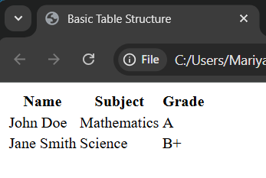
2. 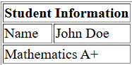

**Basic Form Elements**

1. 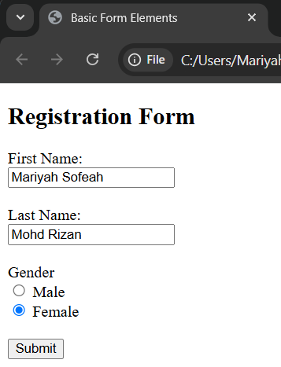
2. 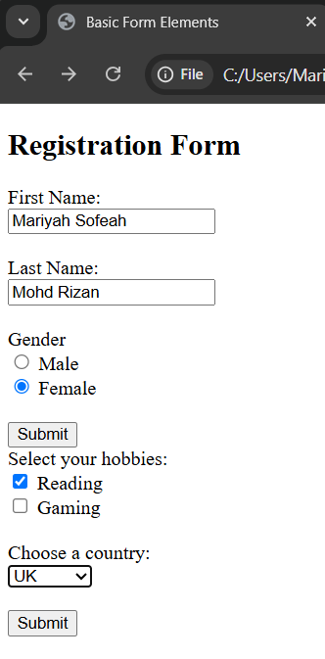

**Semantic HTML**

1. 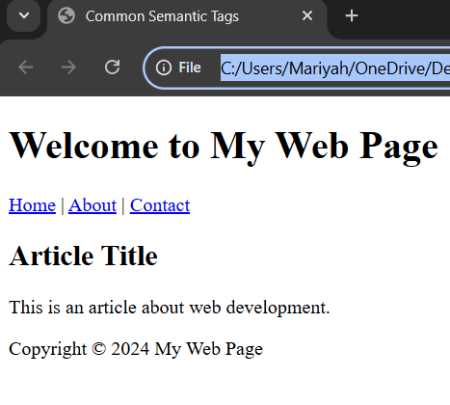

**Lab Exercise 2**

1. Source Code

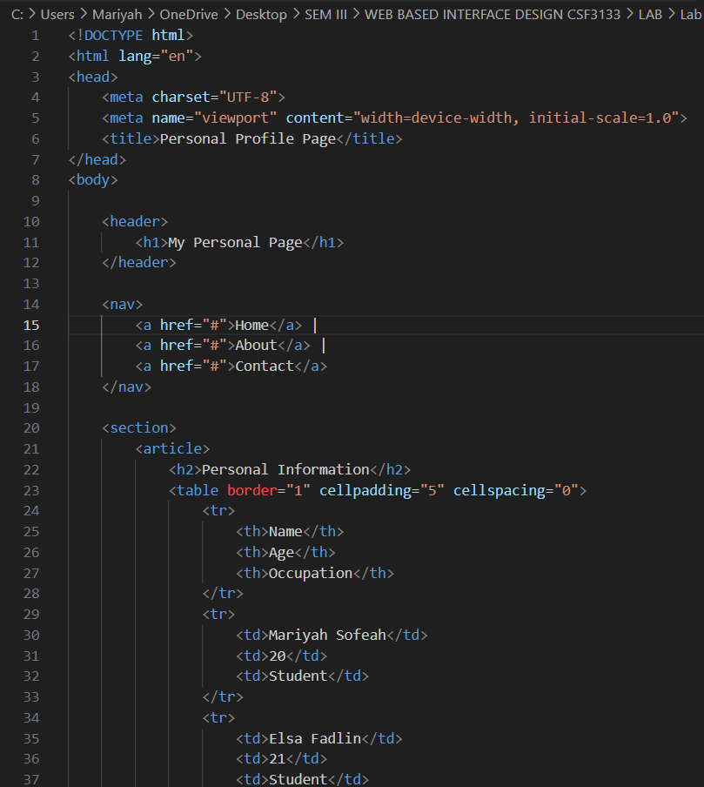

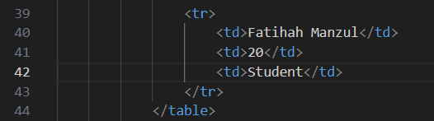

Output

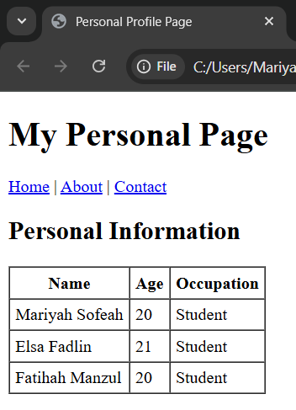

1. Source Code

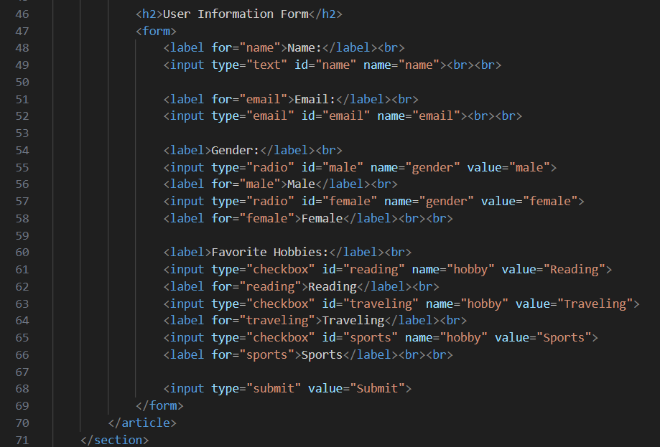

Output

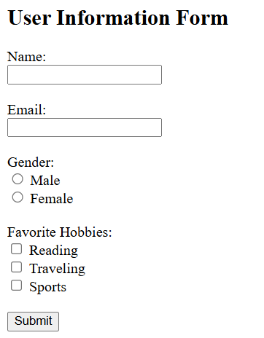

1. Source Code

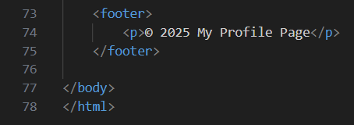

Output

